Images have alternative text | 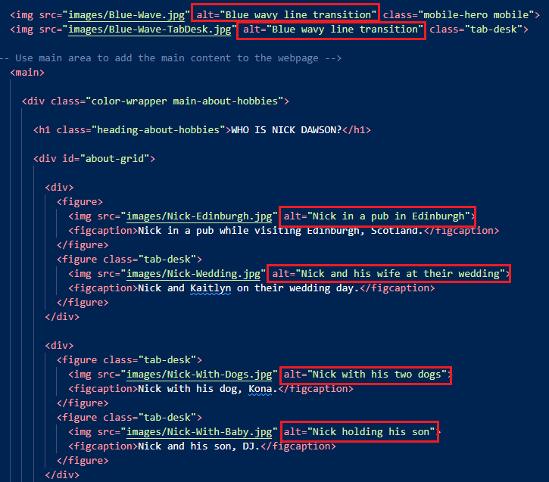
Links are visually identifiable | 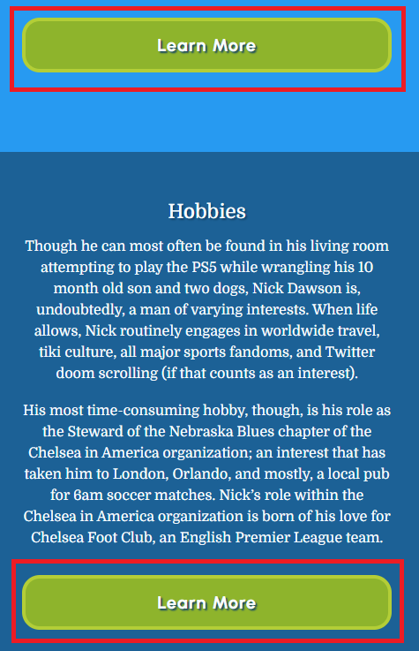
Pages include descriptive section headings | 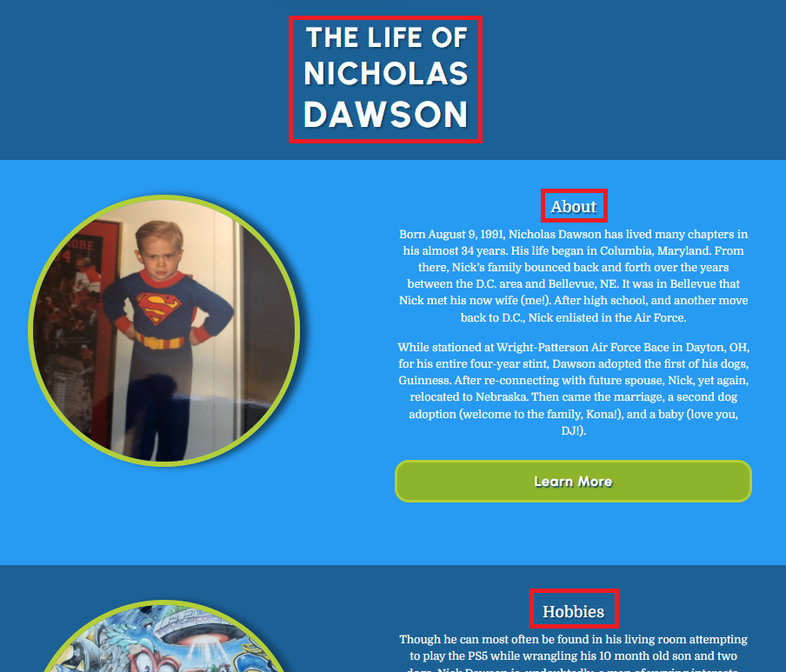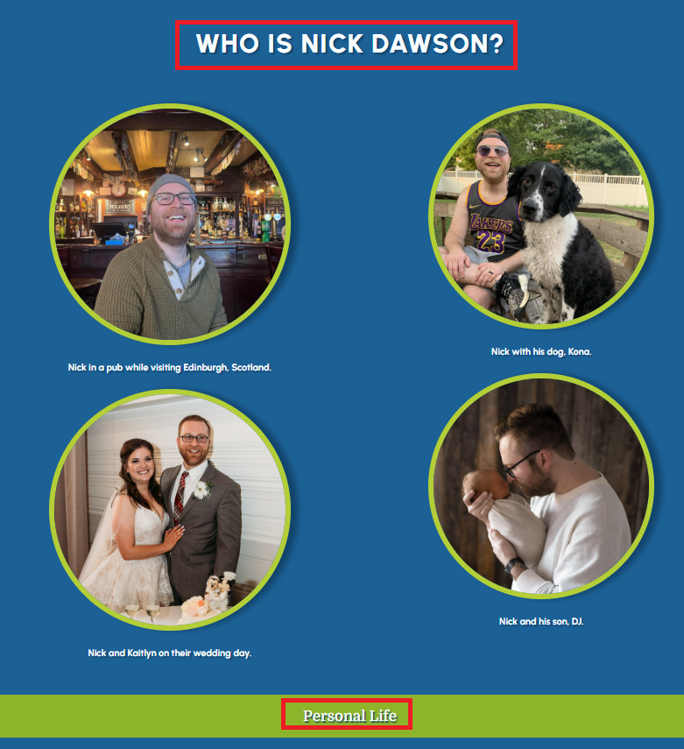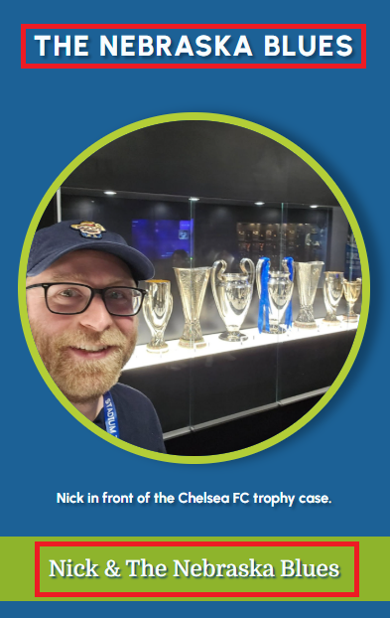
Forms have descriptive labels | N/A
Background and text colors have sufficient contrast | 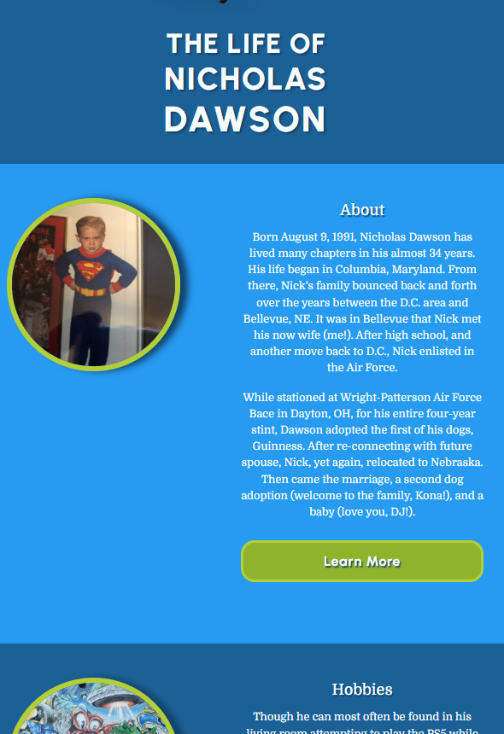
HTML5 input types are used | N/A
Avoids mouse-only interactions | Confirmed – but not sure how to screenshot this.
Uses the HTML lang attribute | 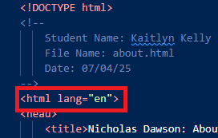
Forms have helpful and accessible error and verification messages | N/A
Links are descriptive and provide intent | 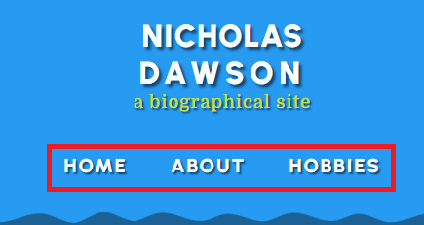  
HTML is valid and error-free | 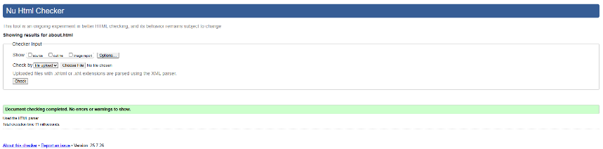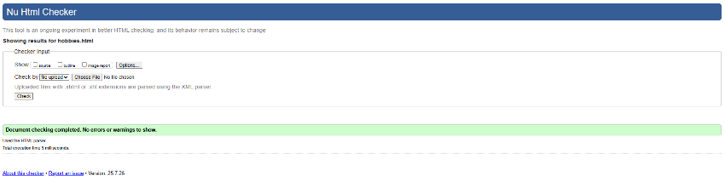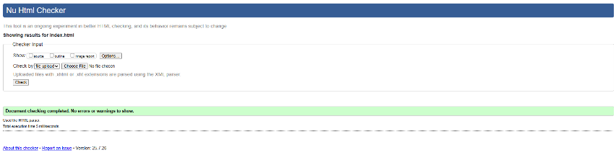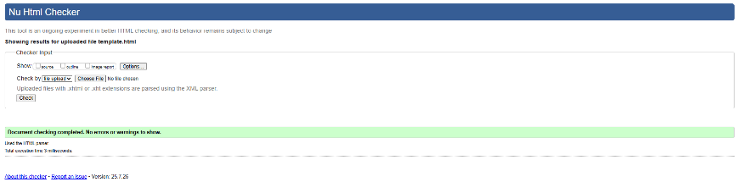
Meta tags are present | 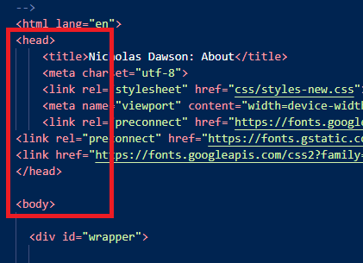
Uses correct semantic HTML element structures | 